

The ministry of physical culture and sports of Ukraine
International dance sport association
City executive administration of Yuzhny
Dance club “PROFI” and dance club “DYNAMO-ILLICHEVSK”

Yuzhny Mayor Cup 2007
15-16 September
Place of carrying out: Yuzhny, sport palace “OLIMP”
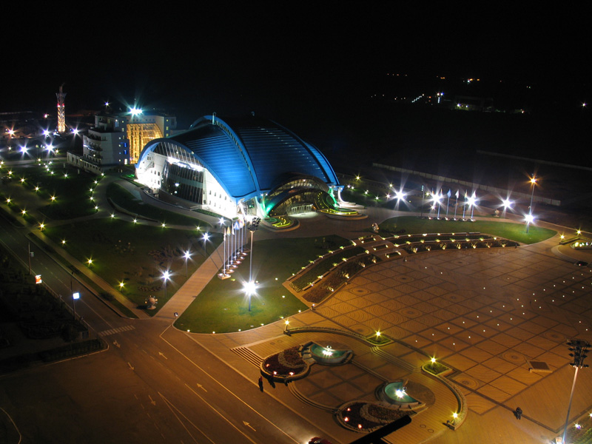
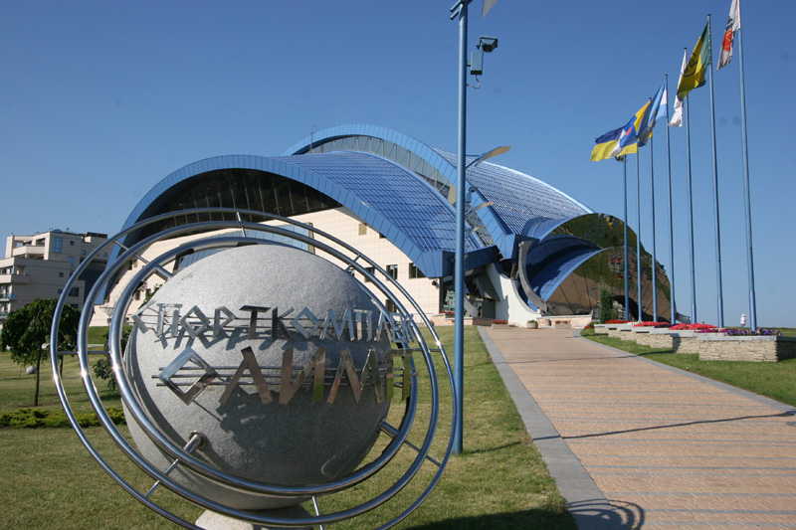
Organizers:

Dance Sport Club “PROFI” Dance Sport Club “Dinamo-Illichevsk”
Mr. Alex Gotsulyak Mr. Victor Paliy
48-1/16, Koroleva str., Odessa 14 Solyana str., Odessa
Ukraine Ukraine
Phone +38 097 3527032 Phone +38 067 7127476
E-mail: algcemcem@mail.ru E-mail: dinamoilichevsk@ukr.net

GROUP | 15 September |  |  | 16 September
GROUP | 09.30 | 15.00 | 19.00 | 09.30 | 15.00 | 19.00
Adults mayor cup |  |  | St |  |  | La
Youth (under 21) mayor cup |  | St |  |  | La
Youth (under 19) mayor cup |  | La | Final | St
Juniors II (under 16) mayor cup |  |  | St |  |  | La
Juniors I (under 14) mayor cup |  |  | St |  |  | La
Juveniles II (under 12) mayor cup |  |  | La |  |  | St
Juveniles I (under 10) mayor cup | St |  |  | La
Juniors II C |  | St |  |  | La
Juniors II D mayor cup |  | St | Final |  | La | Final
Juniors II E | St |  |  | La
Juniors I C |  | St |  |  | La
Juniors I D mayor cup |  | St | Final |  | La | Final
Juniors I E | St |  |  | La
Juveniles I + II D mayor cup | La |  |  | St
Juveniles II E | La |  |  | St
Juveniles I E | La |  |  | St
Juniors I beginners |  | W Q Ch J
Juveniles II beginners |  | W Q Ch J
Juveniles I beginners |  | W Ch J
Children beginners |  |  |  |  | W Ch J
Hobby (after 18) | St |  |  | La
Hobby (under 18) | St |  |  | La
Ukrainian cup Adults | 10 dances | St |  |  | La
Ukrainian cup Youth (under 21) | St |  | 10 dances |  |  | La
Ukrainian cup Youth (under 19) | St |  |  |  | La | 10 dances
Ukrainian cup Juniors II (under 16) |  | St |  | La | 10 dances
Ukrainian cup Juniors I (under 14) |  | 10 dances |  | St | La
Ukrainian cup Juveniles I+II(under 12) |  | 10 dances |  |  | ST,LA
Mayor cup all groups |  |  | W |  |  | S
Girls juveniles I | S Ch J
Girls juveniles II |  |  |  | S Ch J
Girls juniors I | S Ch R J
Girls juniors II |  |  |  | S Ch R J
Judges: all judges from different Associations
Dress: UDSA Rules must be applied!
Starting fee: Per couple for one program:
W and S, Girls- 10 $, Beginners, Е, D,C class – 20 $. Juveniles, Juniors, Hobby--25$. Youth, Adults –30$.
Prizes: Adults major cup – 1 place 800 $, 2 place 500 $, 3 place 300 $, 4 place 200 $, 5 place 150 $, 6 place 100$. Youth (under 21),(under 19)major cup – 1 place 400 $, 2 place 250 $, 3 place 100 $. Juniors II (under 16) major cup – 1 place 300 $, 2 place 200 $, 3 place 100 $. Juniors I (under 14) major cup – 1 place 200 $, 2 place 100 $, 3 place 50 $. For other finalists beautiful prizes, diplomas, medals and cups.
Hotel price: from 7 $ to 200 $ per one person/night. Please, send your entry no later than 20 August 2007.
Entry: Please, send your entry no later than 5 September 2007.
Tickets: from 5$ to 10$. For a reserve of tables call to organizers.

